EXERCISE 3 : STORED PROCEDURES

**SCENARIO 1:** The bank needs to process monthly interest for all savings accounts.

* + **Question:** Write a stored procedure **ProcessMonthlyInterest** that calculates and updates the balance of all savings accounts by applying an interest rate of 1% to the current balance.

**TABLES USED**

CREATE TABLE Accounts (

    AccountID NUMBER PRIMARY KEY,

    CustomerID NUMBER,

    AccountType VARCHAR2(20),

    Balance NUMBER,

    LastModified DATE

);

**INSERTING VALUES INTO THE TABLES**

INSERT INTO Accounts (AccountID, CustomerID, AccountType, Balance, LastModified)

VALUES (1, 1, 'Savings', 1000, SYSDATE);

INSERT INTO Accounts (AccountID, CustomerID, AccountType, Balance, LastModified)

VALUES (2, 2, 'Checking', 1500, SYSDATE);

**CREATE PROCEDURE**

CREATE OR REPLACE PROCEDURE ProcessMonthlyInterest IS

CURSOR savings_cursor IS

SELECT AccountID, Balance FROM Accounts WHERE AccountType = 'Savings';

v_account_id Accounts.AccountID%TYPE;

v_balance Accounts.Balance%TYPE;

v_interest_rate CONSTANT NUMBER := 0.01;

BEGIN

OPEN savings_cursor;

LOOP

FETCH savings_cursor INTO v_account_id, v_balance;

EXIT WHEN savings_cursor%NOTFOUND;

UPDATE Accounts

SET Balance = Balance + (v_balance * v_interest_rate),

LastModified = SYSDATE

WHERE AccountID = v_account_id;

END LOOP;

CLOSE savings_cursor;

COMMIT;

EXCEPTION

WHEN OTHERS THEN

ROLLBACK;

DBMS_OUTPUT.PUT_LINE('Error processing monthly interest: ' || SQLERRM);

END;

/

**RUN THE PROCEDURE**

BEGIN

    ProcessMonthlyInterest;

END;

/

**VIEW RESULT**

SELECT * FROM Accounts;

**OUTPUT**

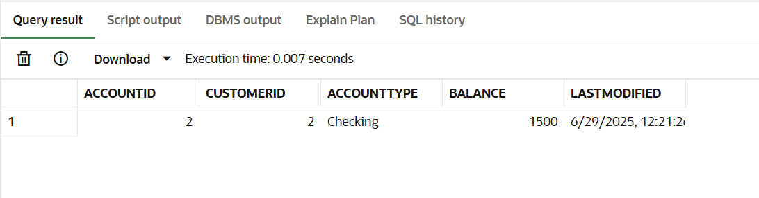

**SCENARIO 2:** The bank wants to implement a bonus scheme for employees based on their performance.

* + **Question:** Write a stored procedure **UpdateEmployeeBonus** that updates the salary of employees in a given department by adding a bonus percentage passed as a parameter.

**TABLES USED**

CREATE TABLE Employees (

    EmployeeID NUMBER PRIMARY KEY,

    Name VARCHAR2(100),

    Position VARCHAR2(50),

    Salary NUMBER,

    Department VARCHAR2(50),

    HireDate DATE

);

**INSERTING VALUES**

INSERT INTO Employees VALUES (1, 'Alice Johnson', 'Manager', 70000, 'HR', TO_DATE('2015-06-15', 'YYYY-MM-DD'));

INSERT INTO Employees VALUES (2, 'Bob Brown', 'Developer', 60000, 'IT', TO_DATE('2017-03-20', 'YYYY-MM-DD'));

**CREATE PROCEDURE**

CREATE OR REPLACE PROCEDURE UpdateEmployeeBonus (

dept_name IN VARCHAR2,

bonus_percent IN NUMBER

) IS

updated_count NUMBER;

BEGIN

UPDATE Employees

SET Salary = Salary + (Salary * bonus_percent / 100)

WHERE Department = dept_name;

updated_count := SQL%ROWCOUNT;

COMMIT;

DBMS_OUTPUT.PUT_LINE(updated_count || ' employee(s) received bonus in department ' || dept_name);

EXCEPTION

WHEN OTHERS THEN

ROLLBACK;

DBMS_OUTPUT.PUT_LINE('Error updating employee bonus: ' || SQLERRM);

END;

/

**RUN THE PROCEDURE**

BEGIN

    UpdateEmployeeBonus('IT', 10);

END;

/

**VIEW RESULT**

SELECT * FROM Employees;

**OUTPUT**

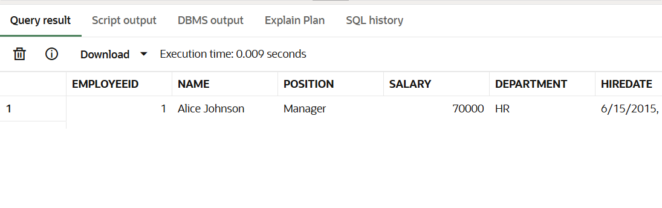

**SCENARIO 3 :** Customers should be able to transfer funds between their accounts.

* + **Question:** Write a stored procedure **TransferFunds** that transfers a specified amount from one account to another, checking that the source account has sufficient balance before making the transfer.

**TABLES USED**

CREATE TABLE Accounts (

    AccountID NUMBER PRIMARY KEY,

    CustomerID NUMBER,

    AccountType VARCHAR2(20),

    Balance NUMBER,

    LastModified DATE

);

CREATE TABLE Transactions (

    TransactionID NUMBER PRIMARY KEY,

    AccountID NUMBER,

    TransactionDate DATE,

    Amount NUMBER,

    TransactionType VARCHAR2(10)

);

**INSERTING VALUES**

-- Accounts

INSERT INTO Accounts VALUES (1, 1, 'Savings', 1000, SYSDATE);

INSERT INTO Accounts VALUES (2, 2, 'Checking', 1500, SYSDATE);

-- Transactions

INSERT INTO Transactions VALUES (1, 1, SYSDATE, 200, 'Deposit');

INSERT INTO Transactions VALUES (2, 2, SYSDATE, 300, 'Withdrawal');

**CREATE PROCEDURE**

CREATE OR REPLACE PROCEDURE TransferFunds (

from_account_id IN NUMBER,

to_account_id IN NUMBER,

amount IN NUMBER

) IS

insufficient_balance EXCEPTION;

account_not_found EXCEPTION;

from_balance NUMBER;

to_count NUMBER;

BEGIN

SELECT Balance INTO from_balance

FROM Accounts

WHERE AccountID = from_account_id

FOR UPDATE;

SELECT COUNT(*) INTO to_count

FROM Accounts

WHERE AccountID = to_account_id;

IF to_count = 0 THEN

RAISE account_not_found;

END IF;

IF from_balance < amount THEN

RAISE insufficient_balance;

END IF;

UPDATE Accounts

SET Balance = Balance - amount,

LastModified = SYSDATE

WHERE AccountID = from_account_id;

UPDATE Accounts

SET Balance = Balance + amount,

LastModified = SYSDATE

WHERE AccountID = to_account_id;

INSERT INTO Transactions

VALUES (Transactions_seq.NEXTVAL, from_account_id, SYSDATE, amount, 'Debit');

INSERT INTO Transactions

VALUES (Transactions_seq.NEXTVAL, to_account_id, SYSDATE, amount, 'Credit');

COMMIT;

EXCEPTION

WHEN insufficient_balance THEN

ROLLBACK;

DBMS_OUTPUT.PUT_LINE('Transfer failed: insufficient funds.');

WHEN account_not_found THEN

ROLLBACK;

DBMS_OUTPUT.PUT_LINE('Transfer failed: destination account not found.');

WHEN OTHERS THEN

ROLLBACK;

DBMS_OUTPUT.PUT_LINE('Transfer failed due to an unexpected error: ' || SQLERRM);

END;

/

**RUN THE PROCEDURE**

BEGIN

    TransferFunds(1, 2, 300); -- Transfer $300 from account 1 to 2

END;

/

**VIEW RESULT**

SELECT * FROM Accounts;

SELECT * FROM Transactions;

**OUTPUT**

